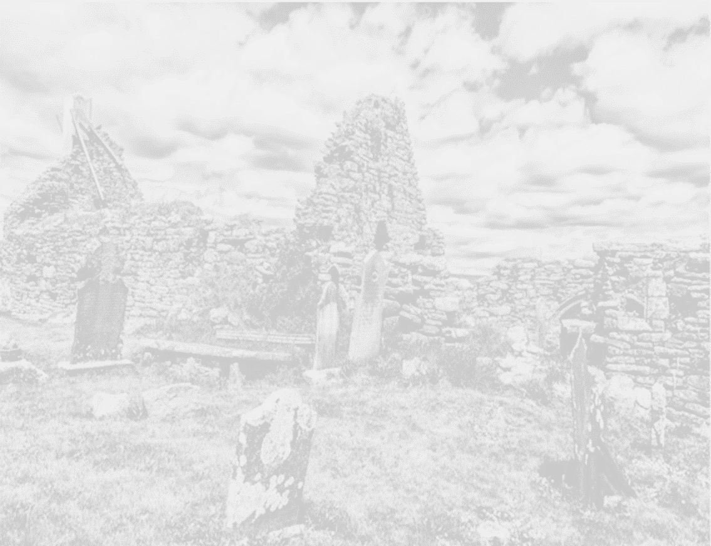
A photography competition for exhibition

Date: Click here to enter text.
Name: Click here to enter text.
Address: Click here to enter text.
Email address: Click here to enter text.
Telephone number:

Categories entered:
Coastal Landscape ☐ Wildlife and Nature ☐
People from our Landscape ☐ Built Heritage ☐

I confirm, if selected for the last ten in a category or for the ‘People’s Choice’, I will supply to Hook Tourism, an A4 (8” x 12”) print for exhibition ☐
I confirm that I have read and agree to the terms & conditions of this competition ☐
I confirm that I want my photo to be available for purchase ☐
Please specify how much you would like to sell your photo/s for €_______
I understand that Hook Tourism will hold 15% of any sale price as commission ☐
I accept that by emailing this completed form along with my photo entry to marketing@hooktourism.com I understand and agree with all of the above conditions.

Terms and Conditions
All entries should be e-mailed to marketing@hooktourism.com. The photograph should be accompanied by a caption, the name of the person who took the picture and the location. The photographer will always retain full copyright of their image. Only one photo entry per person per category and the closing date for electronic entries is Friday 19th August. Ten entries from each category will be announced on Friday 2nd September and if chosen, you agree to supply to Hook Tourism, a printed A4 size photograph by Friday 30th September.

* All photographs submitted must be the work of the individual who submits them. Entrants must ensure that photographs of people have been taken with the permission of the subject (where identifiable).
* All photographs must have been taken between 1st August 2015 and Friday 19th August 2016.
* All photographs must have been taken on the Hook Peninsula or of the Hook Peninsula or of waters surrounding the Hook Peninsula (including Bannow Bay).
* No excessively digitally altered images will be accepted (no cloning, adding or removing elements). Basic enhancements are allowed, for example brightness, contrast, and sharpening etc.
* All pictures should be submitted as JPEG files (.jpg). Please include a caption to explain your picture.
* You warrant to us that all contributions are lawful and do not infringe any rights of any third party and that you will indemnify us in respect of any breach of that warranty.
* Hook Tourism accepts no liability for any content submitted by third parties.
* You will not submit a photograph that is offensive, abusive, indecent, defamatory or obscene.
* You license us to use the photograph you provide on our website and social media accounts and for more than once. The photographs may be used to promote the photography competition, exhibition and to promote the Hook Peninsula to potential visitors.
* You accept that we may exercise editorial control over the photograph and may decide not to allow publication at our absolute discretion.
* Judges decision is final.
* Hook Tourism retains the right to reject or disqualify a picture from the competition.
* One entry per person, per category of which there are 4 categories.
* By entering this competition, you agree to all of the above terms and conditions.

